***Section 8 – Testing***

Testing Plan

I will evaluate my system by executing each of the objectives.

Testing will encompass assessing the software program's functionality during its execution. For each tested data input, I will incorporate Normal, Erroneous, and Extreme values to check if the system component successfully passes through the testing phase.

1. **Data storage**

|  |  |  |  |  |  |  |
| --- | --- | --- | --- | --- | --- | --- |
| Test Number | Test Purpose | Reason | Entry | Entry Type | Expected result | Test Result |
| 1 | To check if the Database has been created | Check if correct tables have been created |  |  |  | Passed Test |

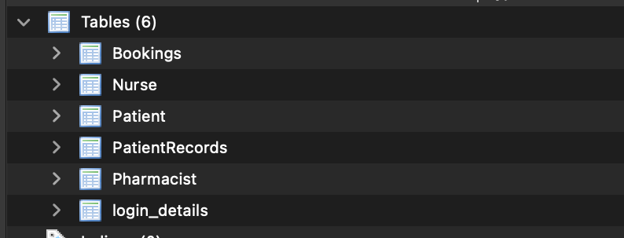

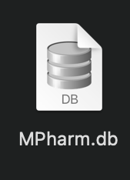

As you can see above all the correct tables have been made and the MPharm.db file has been created.

1. **Data input**

|  |  |  |  |  |  |  |
| --- | --- | --- | --- | --- | --- | --- |
| Test Number | Test Purpose | Reason | Entry | Entry Type | Expected result | Test Result |
| 2. | Making sure patient details are added to the system | Type in Patient details | Tom  Hardy  15/01/1986  32 Grafting Street  BT35 8LW  06337338838  02835883778  Thardy667@gmail.com | Normal | Details are added to the system | Passed |
| 3. | Display an error if a field is left empty | Leave out patient Firstname |  | Erroneous | Error message appears | Passed |
| 4. | Display an error is the wrong month has been entered | Enter 13 in the month field | 15/ 13 /1986 | Erroneous | Error message appears | Passed |
| 5. | System validates the postcode | Enter an invalid postcode | Ft564577787 | Erroneous | Error message appears | Passed |
| 6. | System adds Pharmacist to the Pharmacist Table | Enter Pharmacist Details | Ben  Murphy  23 Molly Rd  BT35 9LK  Queens  Bachelors | Normal | Details are added to the system | Passed |
| 7. | System validates presence | Leave out pharmacist surname |  | Erroneous | Error message appears | Passed |
| 8. | System adds Booking details to the Bookings Table | Enter Booking Details | 3  2  1  09/02/2024  09:25  Vaccine | Normal | Details are added to the system | Passed |
| 9. | System validates the time | Enter wrong time | 72:00 | Erroneous | Error message appears | Passed |
| 10. | System adds nurse details to the system | Enter Nurse details | Jessica  Larkin  22 Carrick Lane  BT35 7WR  06551552245  02/11/2020  Ulster University | Normal | Details are added | Passed |
| 11. | System adds Patient records to the database | Enter Patient record Details | 5  6  11/11/2023  HIV  Very Serious  13/11/2022 | Normal | Details are added | Passed |

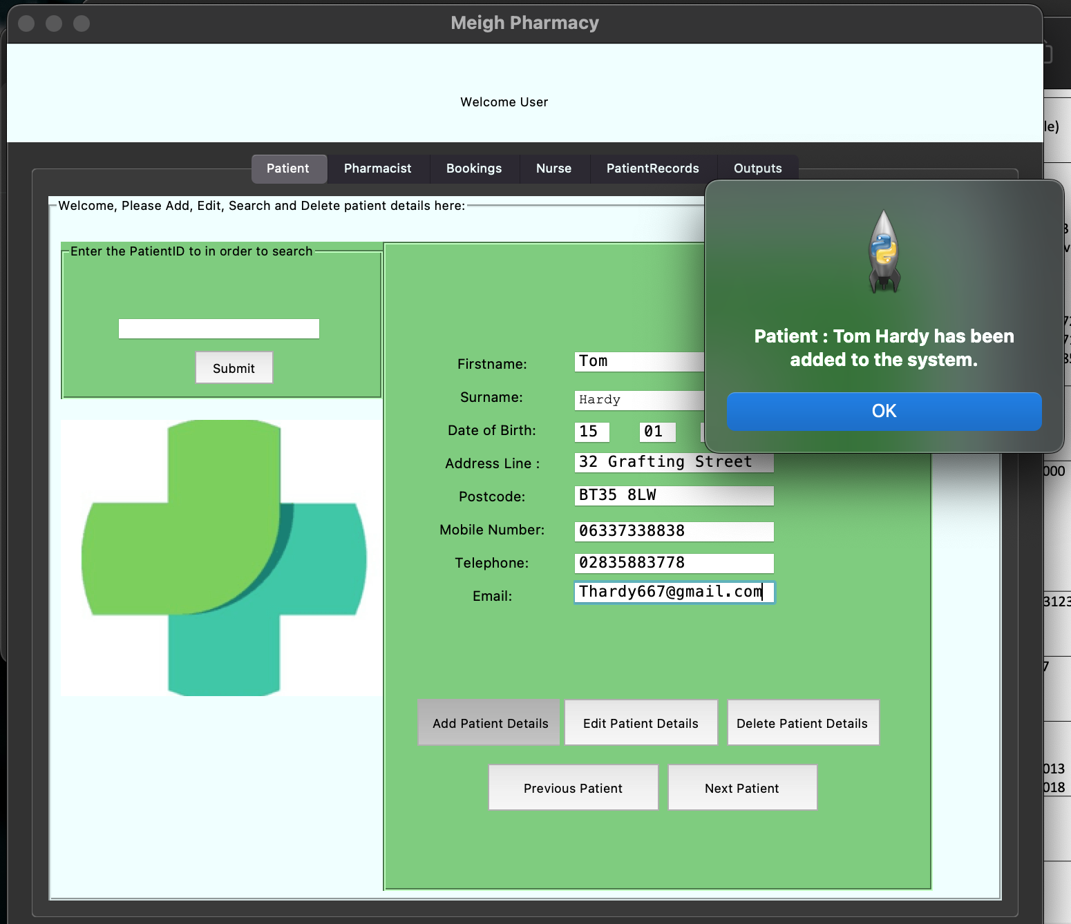

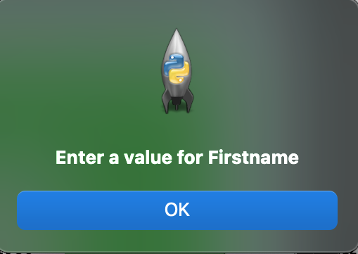

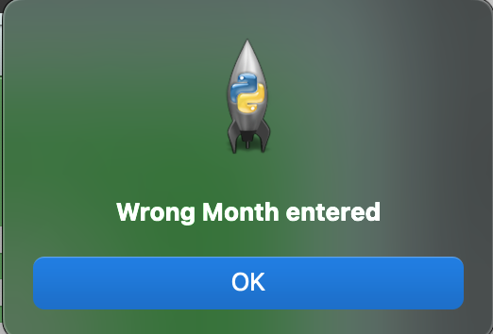

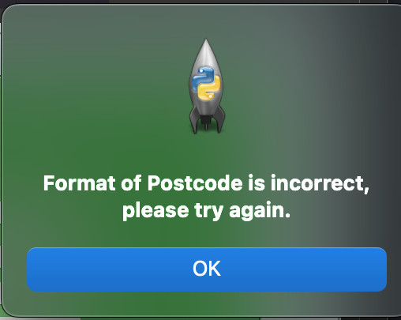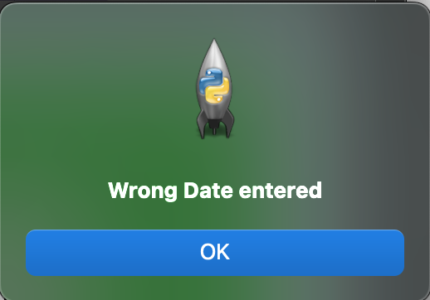

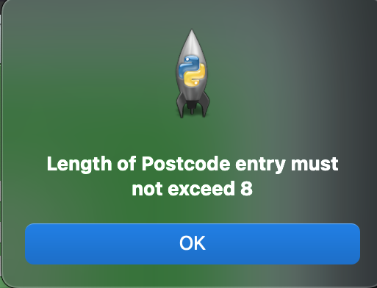

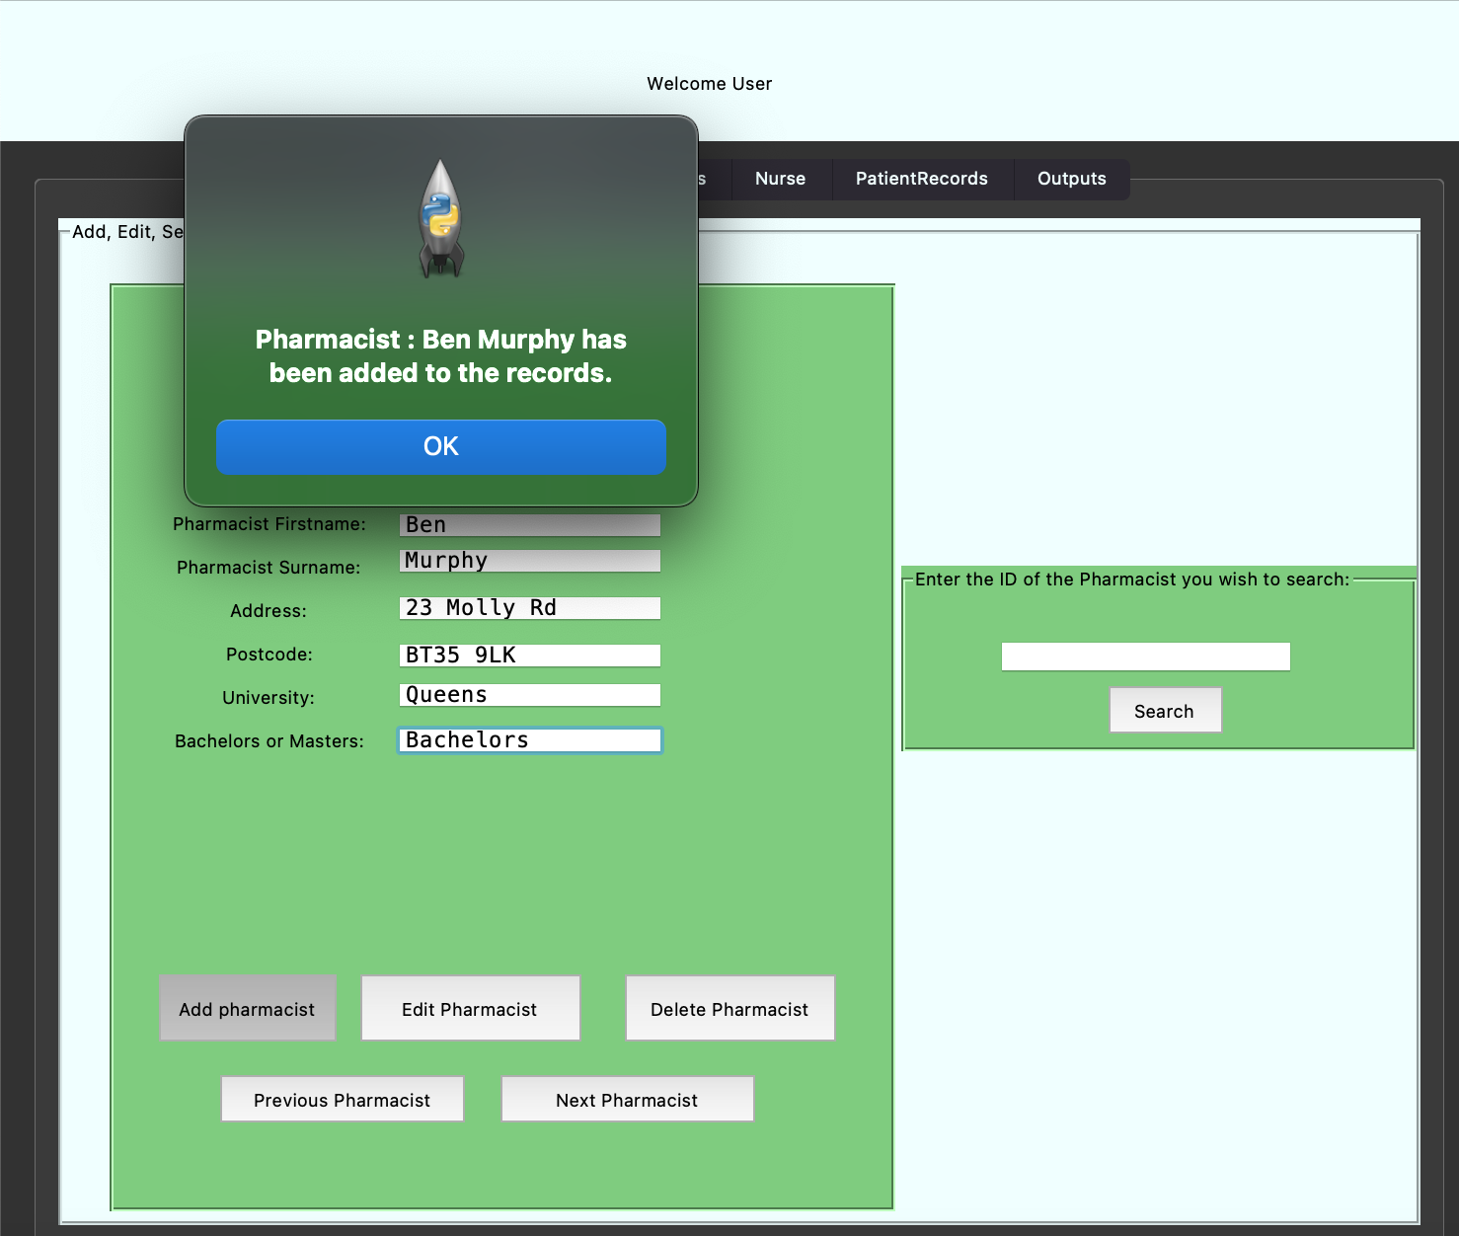

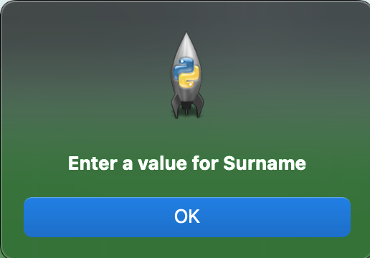

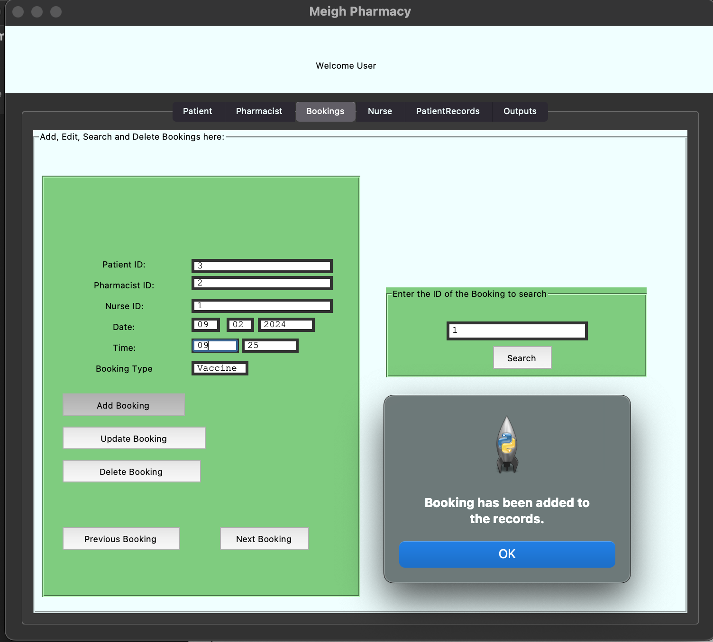

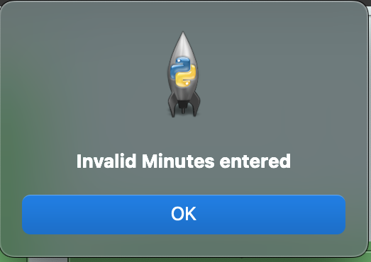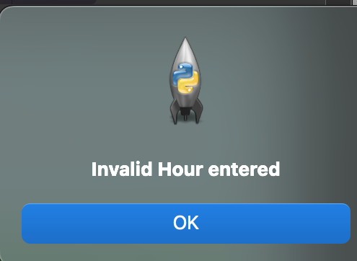

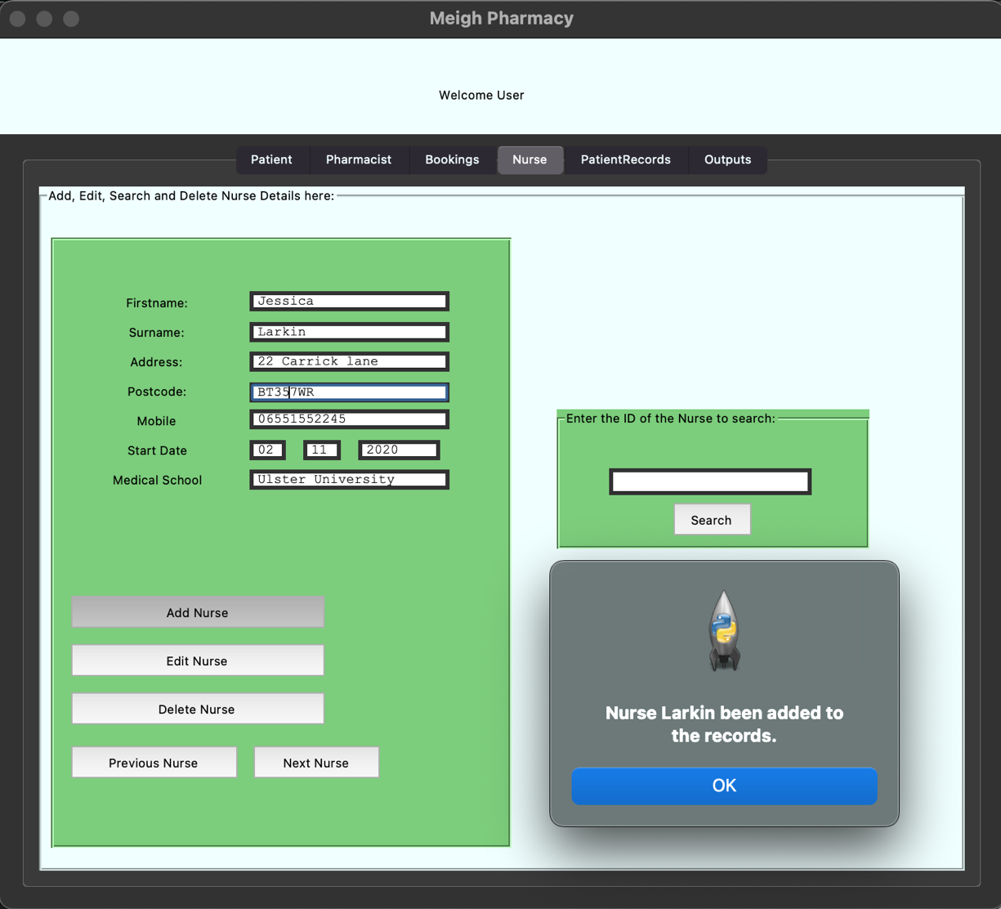

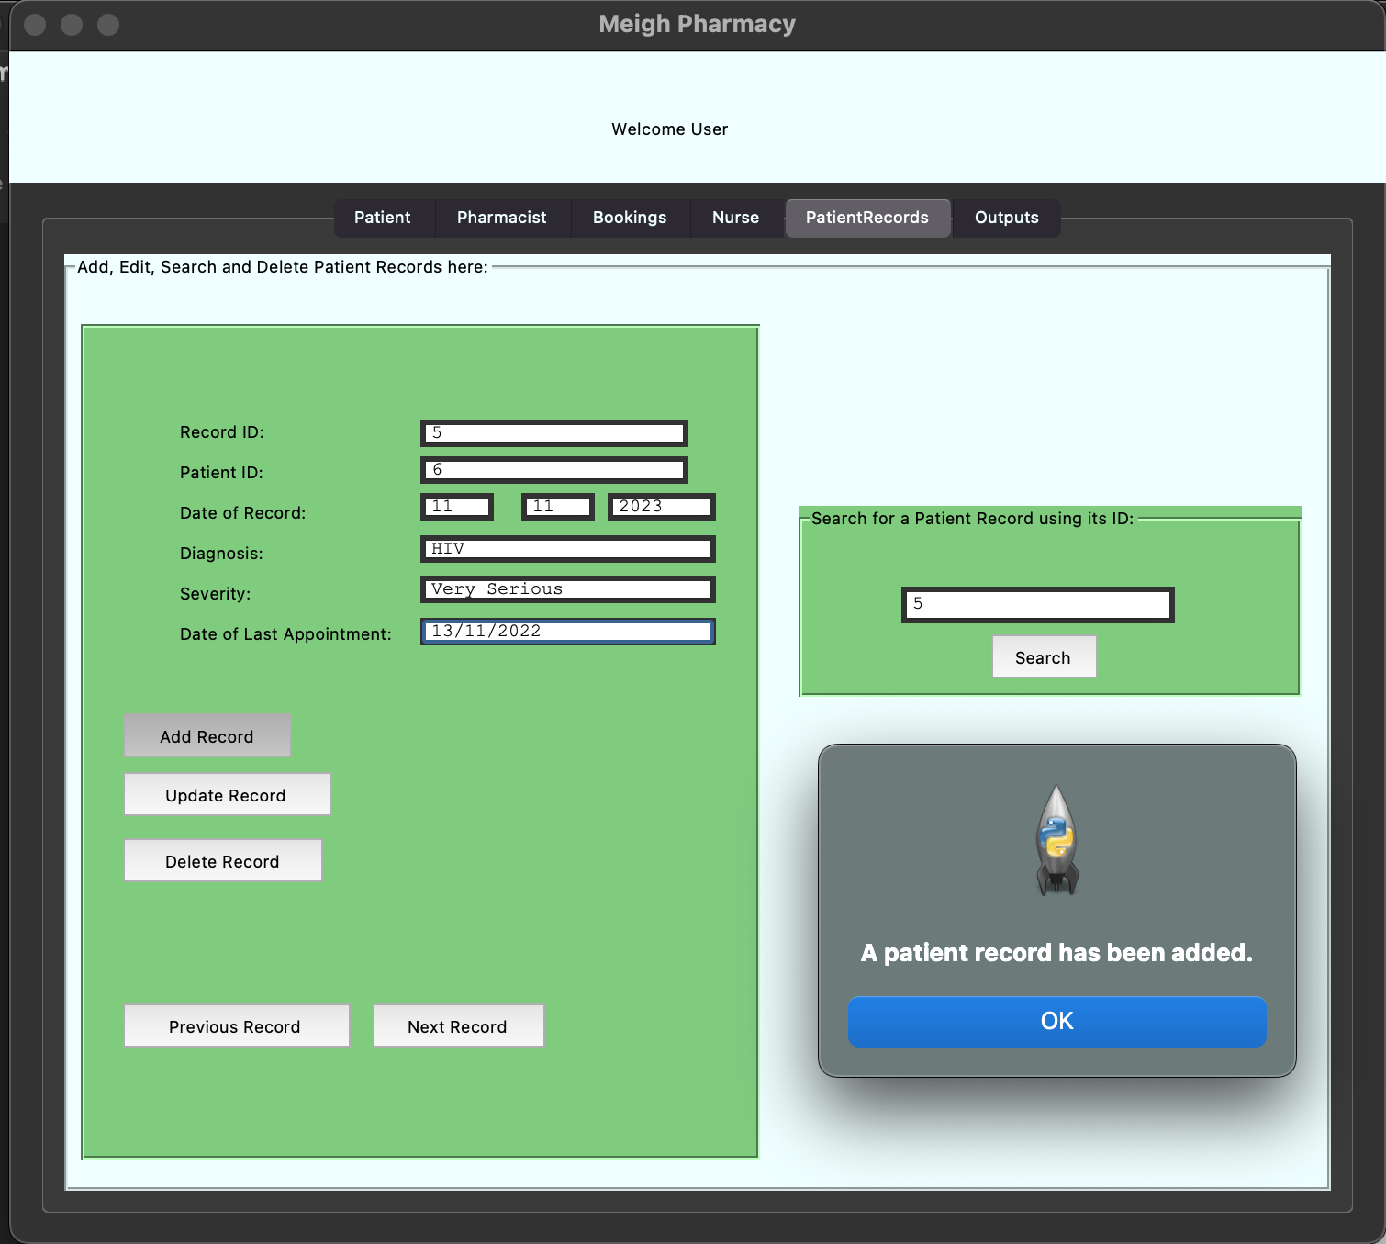

1. **Data manipulation**

|  |  |  |  |  |  |  |
| --- | --- | --- | --- | --- | --- | --- |
| Test Number | Test Purpose | Reason | Entry | Entry Type | Expected result | Test Result |
| 12. | Entry fields are filled with the correct data when searching | Enter 2 into Patient search | 2 | Normal | Entry Fields are populated with data | Passed |
| 13. | Entry fields are filled with the correct data when searching | Enter 1 into Pharmacist search | 1 | Normal | Entry Fields are populated with data | Passed |
| 14. | Entry fields are filled with the correct data when searching | Enter 1 into Bookings search | 1 | Normal | Entry Fields are populated with data | Passed |
| 15. | Entry fields are filled with the correct data when searching | Enter 2 into Nurse search | 2 | Normal | Entry Fields are populated with data | Passed |
| 16. | Entry fields are filled with the correct data when searching | Enter 1 into Patient records search | 1 | Normal | Entry Fields are populated with data | Passed |
| 17. | Database updates Patient Details | Change the Firstname of Patient 7 to Thomas | Thomas | Normal | Data is Updated | Passed |
| 18. | Database updates Pharmacist Details | Change the surname of Pharmacist 2 to McCoy | McCoy | Normal | Data is Updated | Passed |
| 19. | Database updates Booking Details | Change the booking of booking 1 time to 13:45 | 13:45 | Normal | Data is Updated | Passed |
| 20. | Database updates Nurse Details | Change the medical school value for nurse 2 to Cork University | Cork University | Normal | Data is Updated | Passed |
| 21. | Database updates Patient record Details | Change the severity value for Patient record 1 to Diabetes | Diabetes | Normal | Data is Updated | Passed |

**Images of the Searching Functions passing their tests**

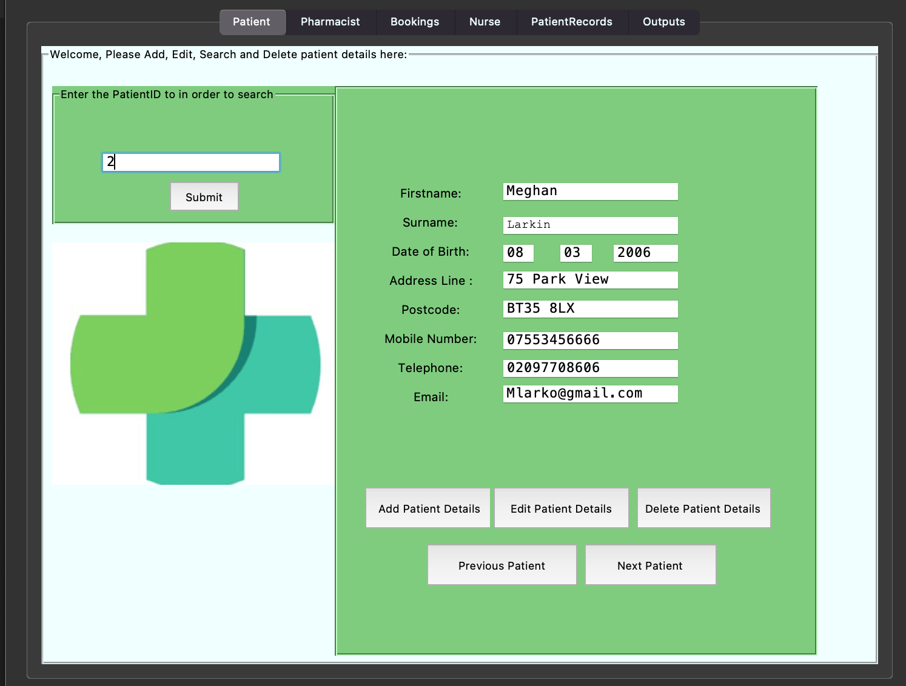

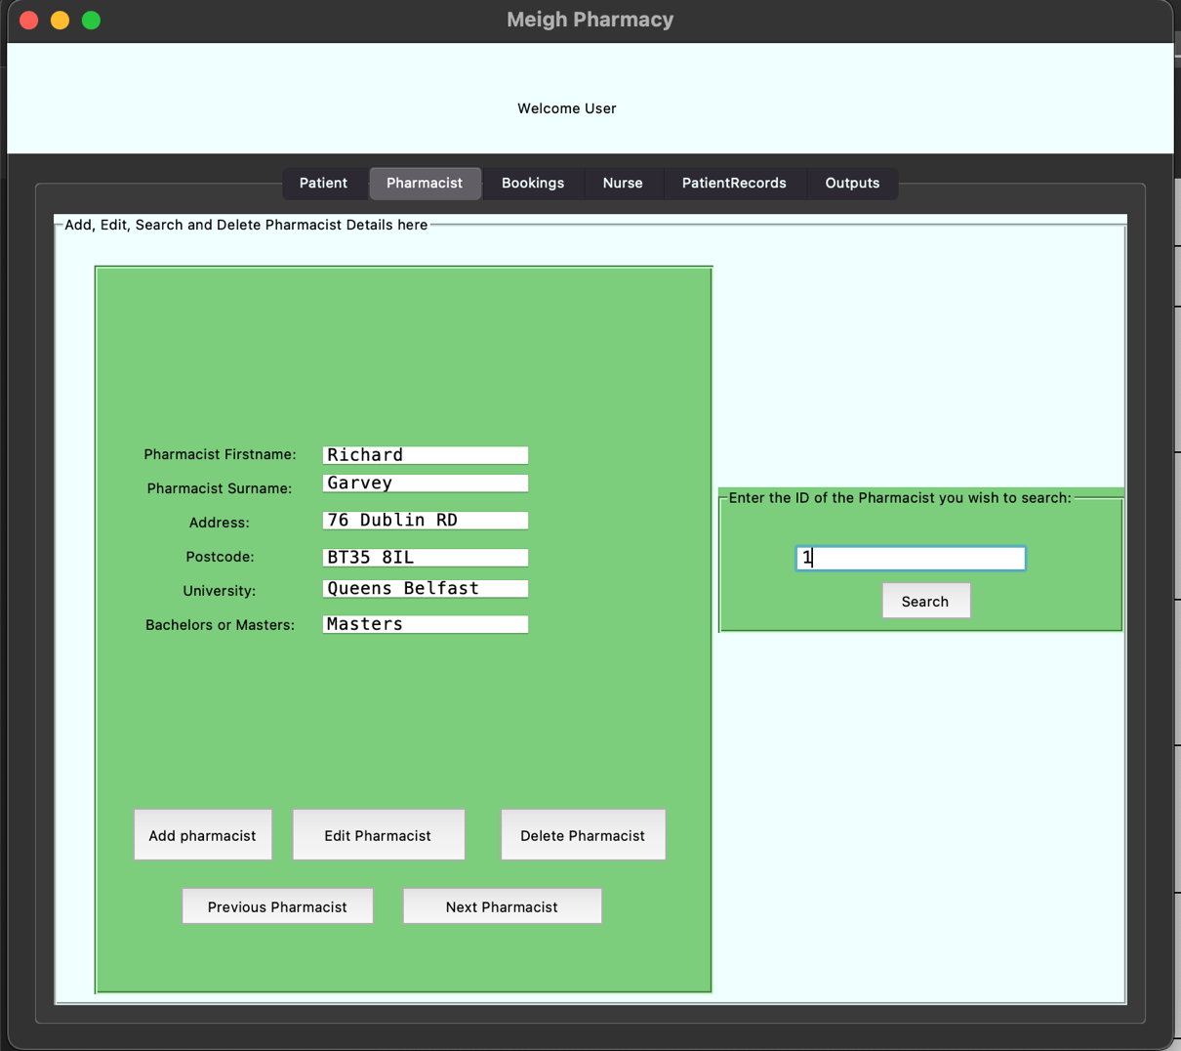

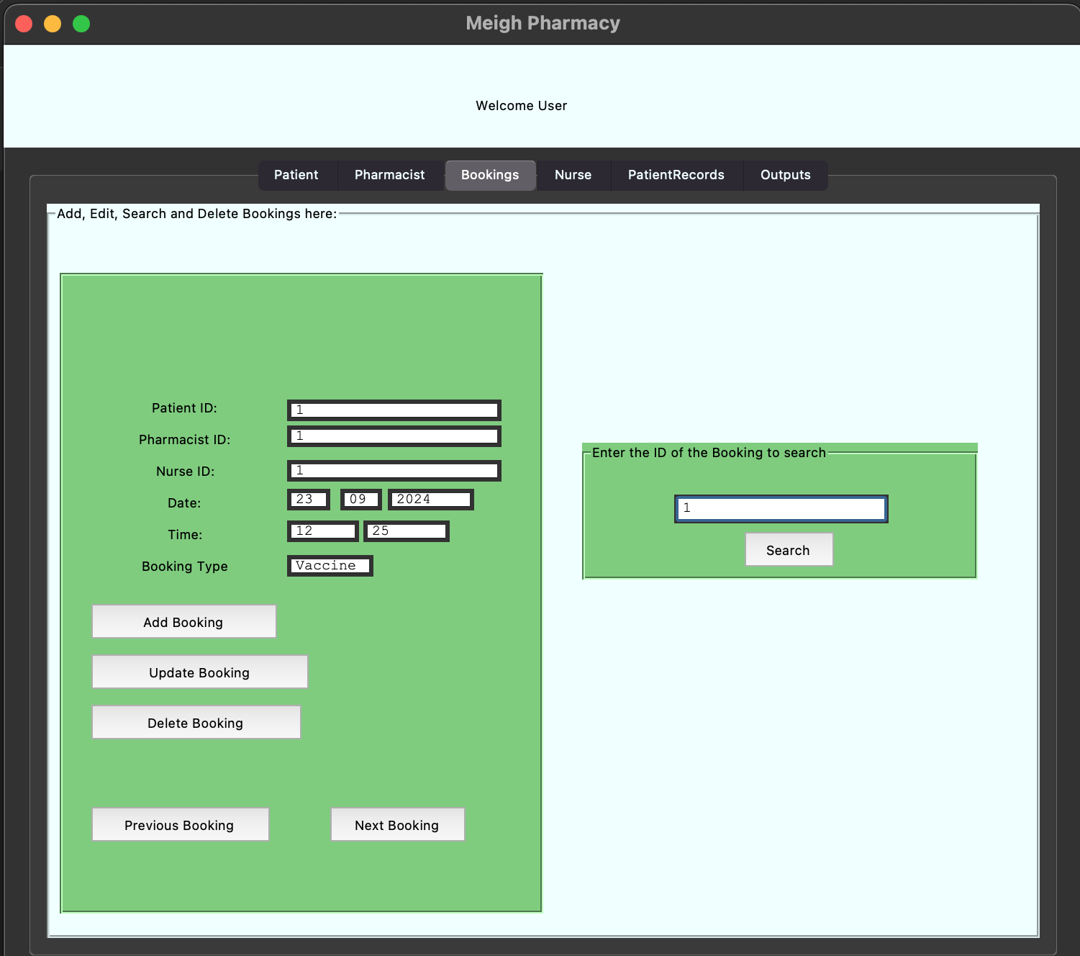

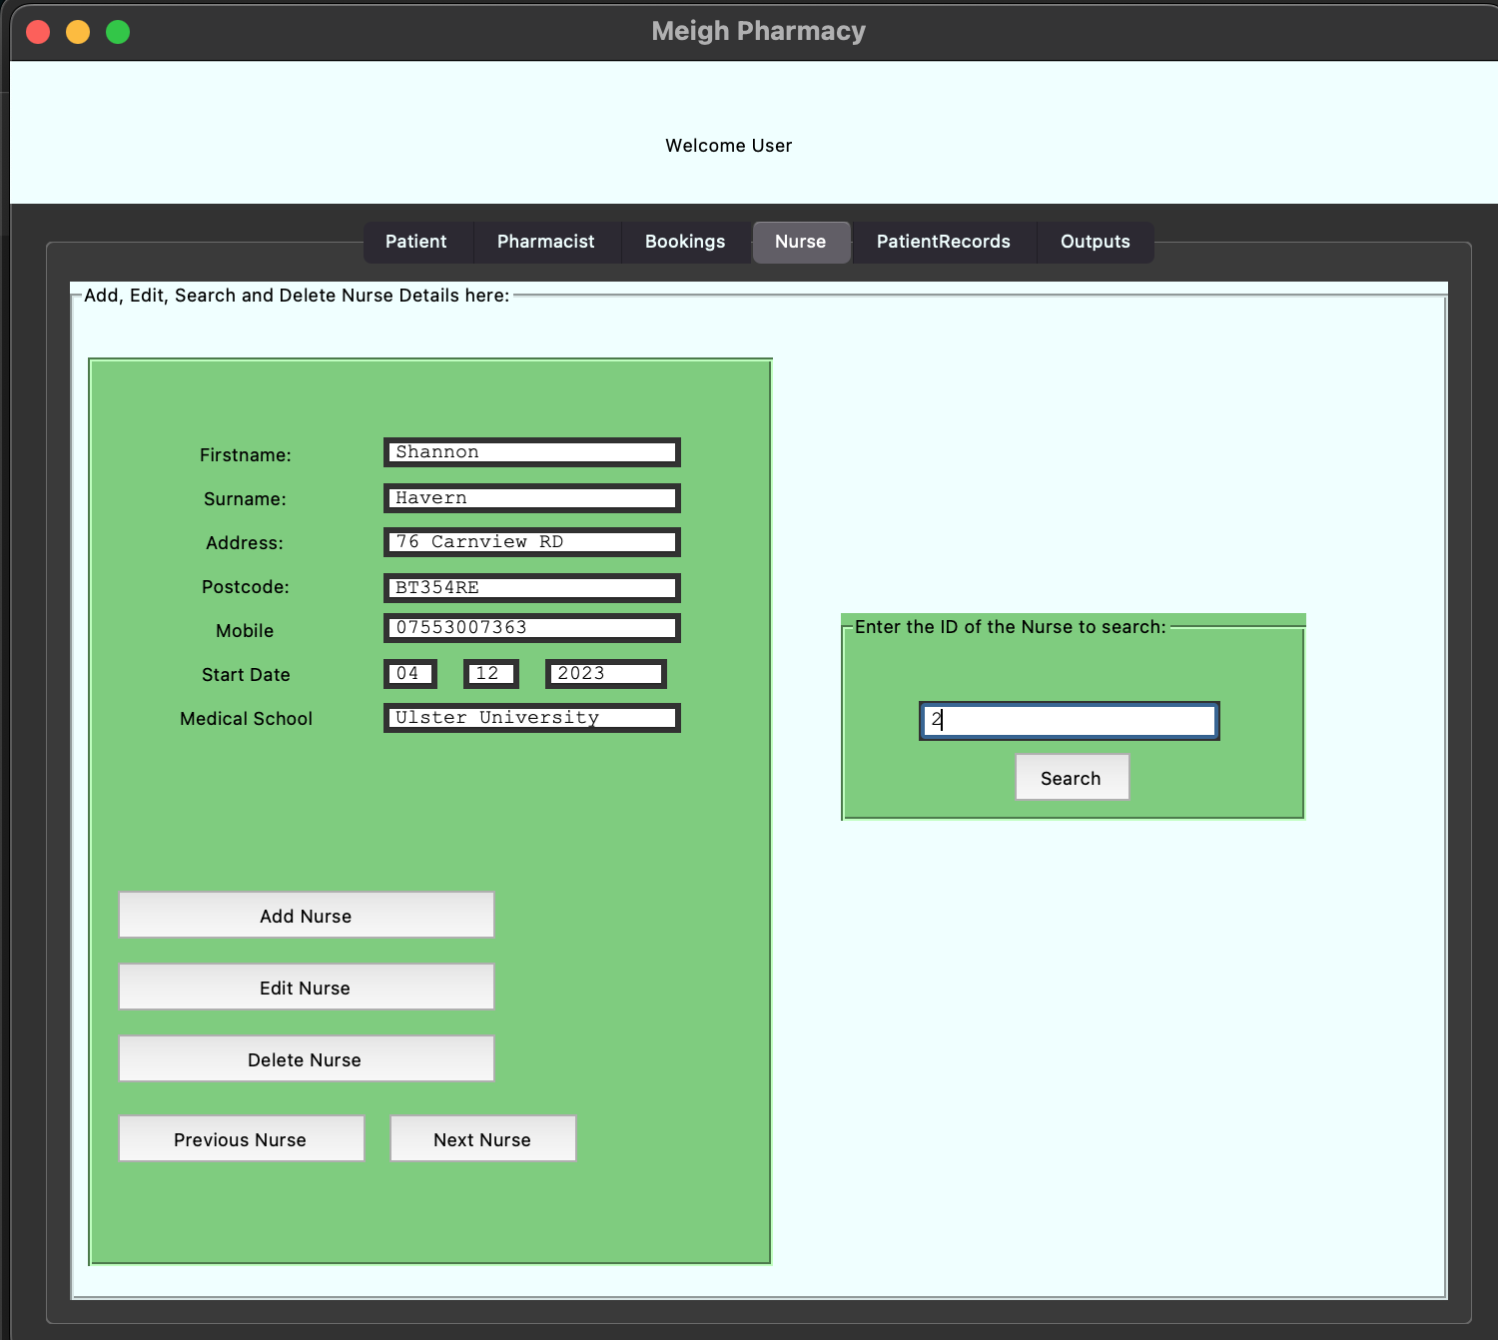

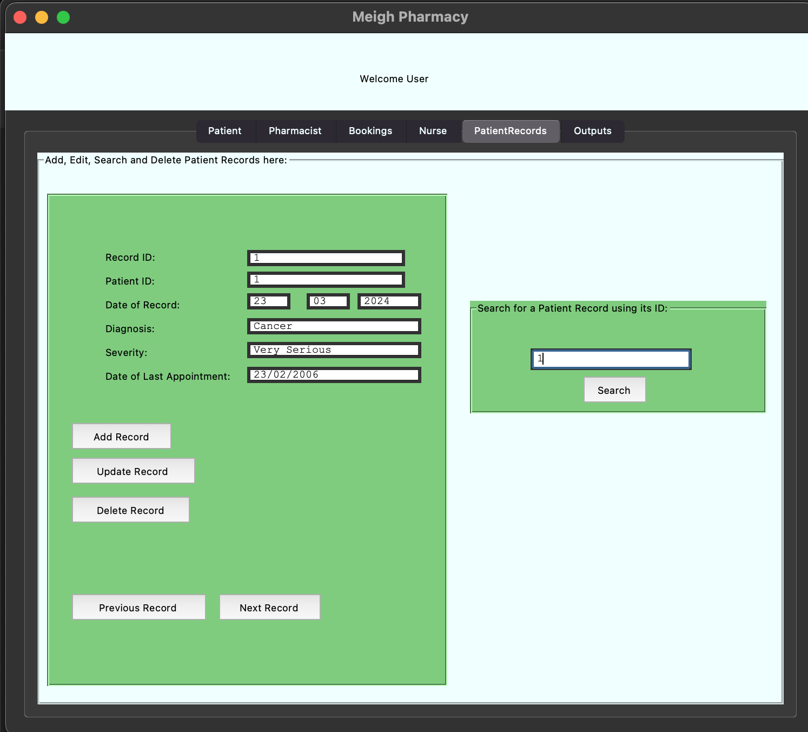

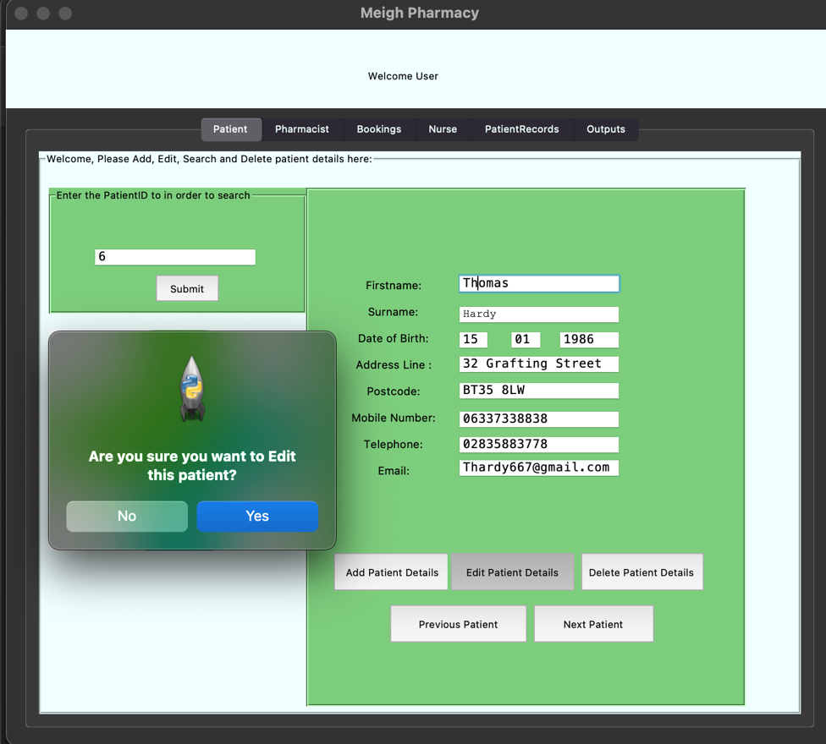**Images of Editing and Updating to the Database:**

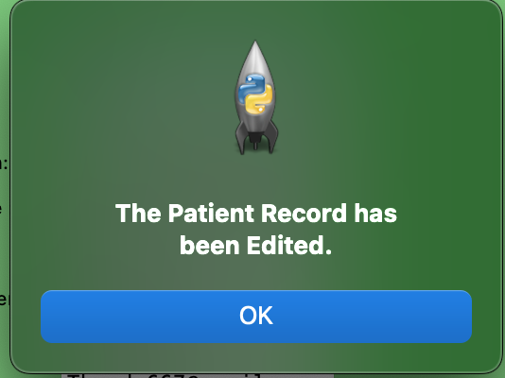

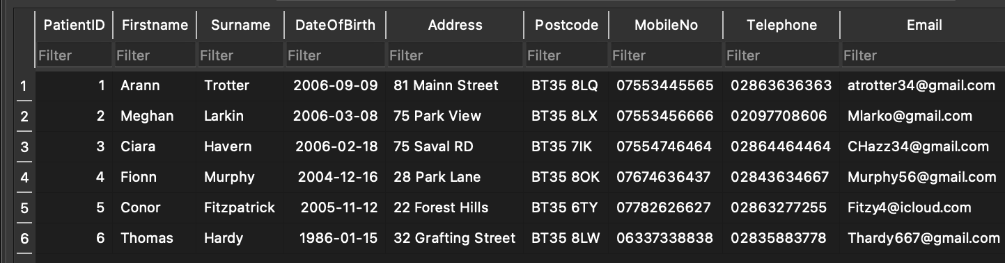

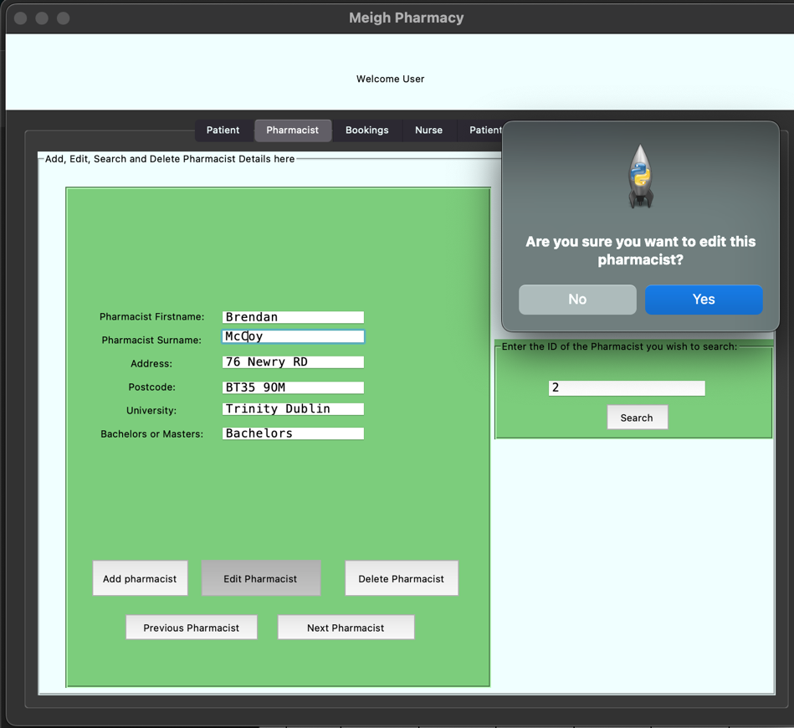Pharmacist:

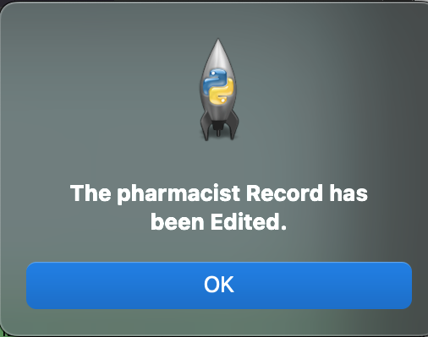

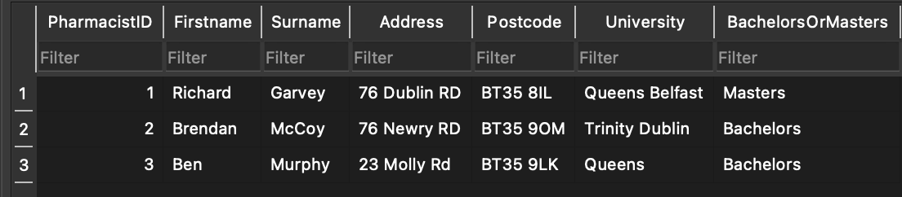

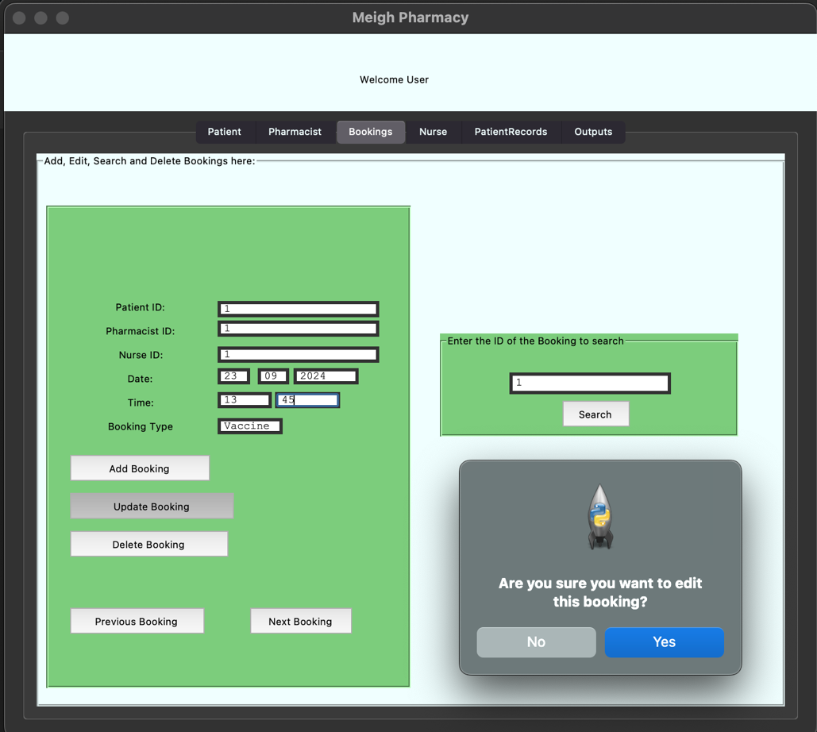Bookings:

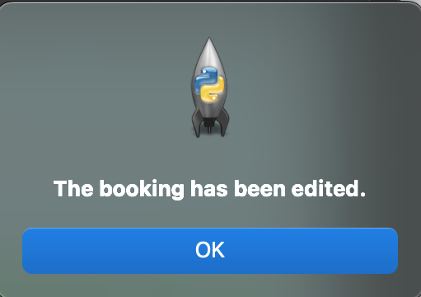

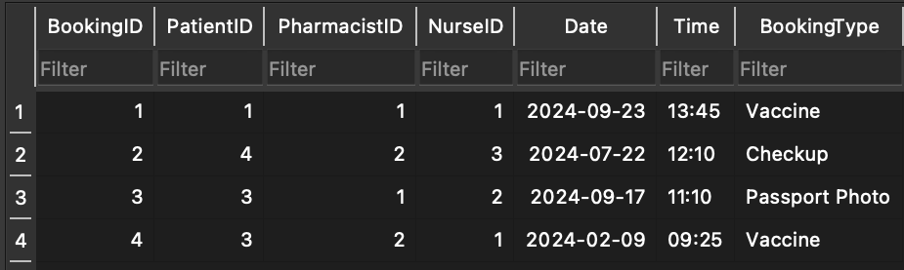

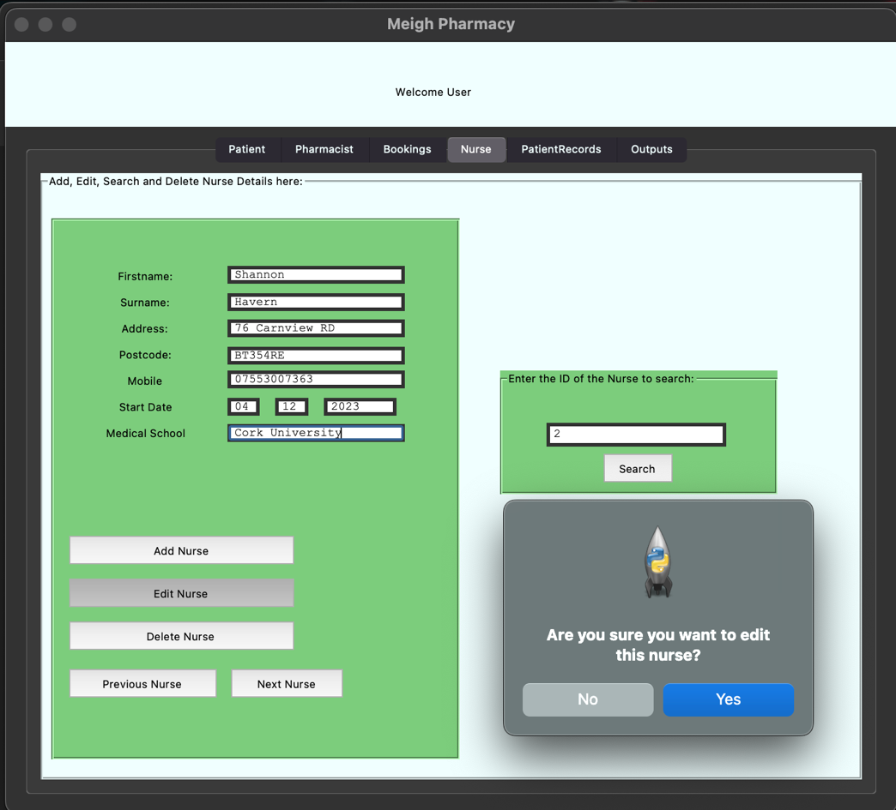Nurse:

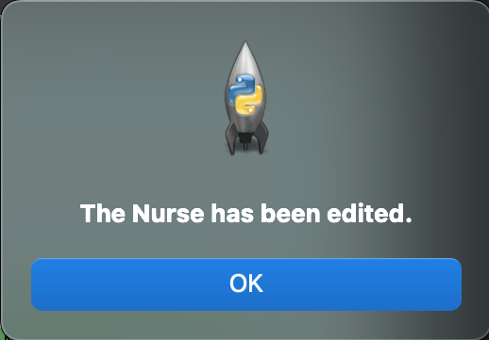

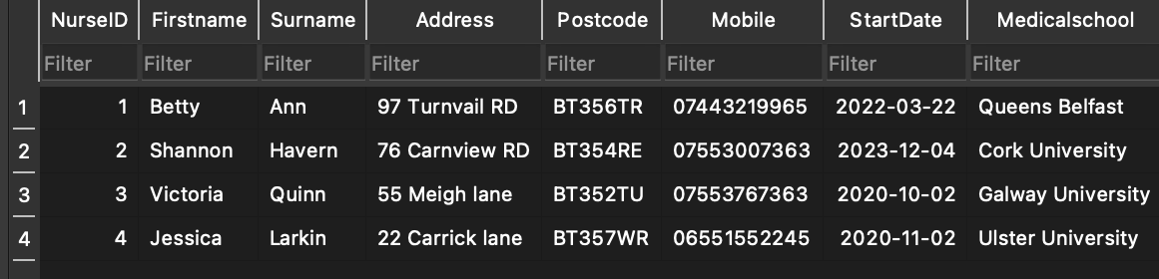

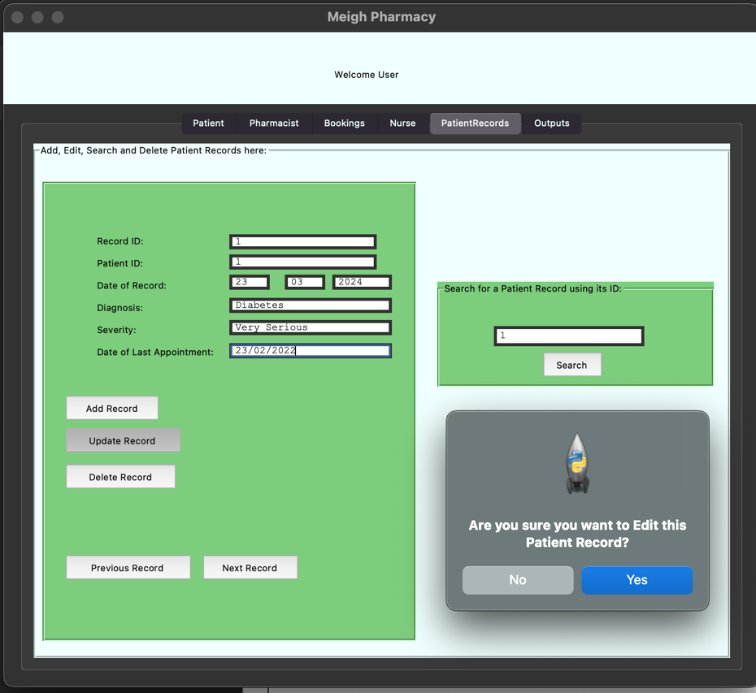Patient Records:

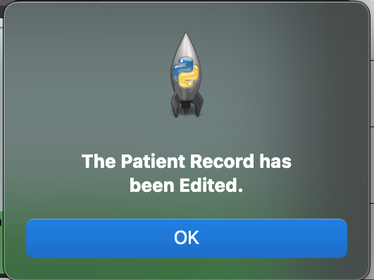

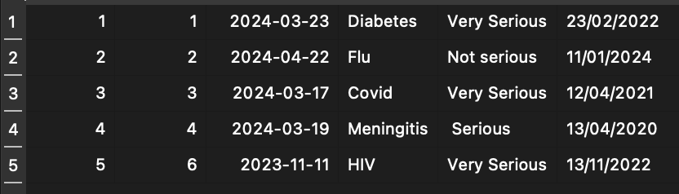

|  |  |  |  |  |  |  |
| --- | --- | --- | --- | --- | --- | --- |
| Test Number | Test Purpose | Reason | Entry | Entry Type | Expected result | Test Result |
| 22. | System Deletes Patient data | Press the delete button to delete the already searched data |  |  | Data is deleted from the Database; message pops up to tell us | Passed |
| 23. | System Deletes Pharmacist data | Press the delete button to delete the already searched data |  |  | Data is deleted from the Database; message pops up to tell us | Passed |
| 24. | System Deletes Booking Data | Press the delete button to delete the already searched data |  |  | Data is deleted from the Database; message pops up to tell us | Passed |
| 25. | System Deletes Nurse Data | Press the delete button to delete the already searched data |  |  | Data is deleted from the Database; message pops up to tell us | Passed |
| 26. | System Deletes Patient record data | Press the delete button to delete the already searched data |  |  | Data is deleted from the Database; message pops up to tell us | Passed |

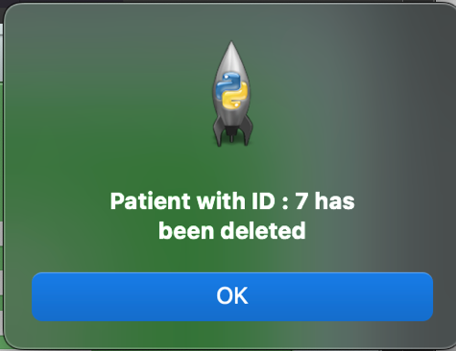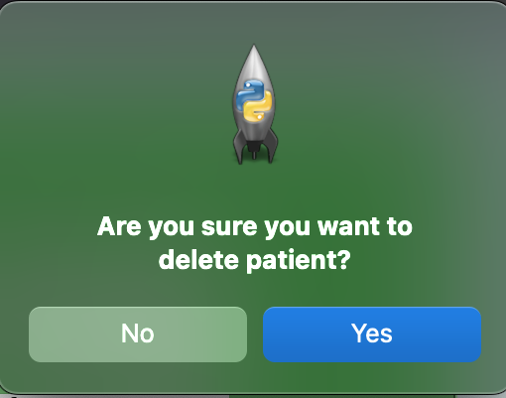

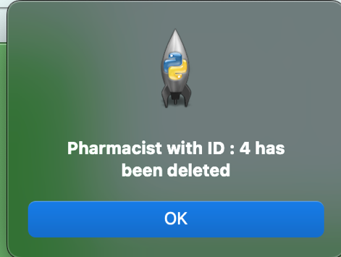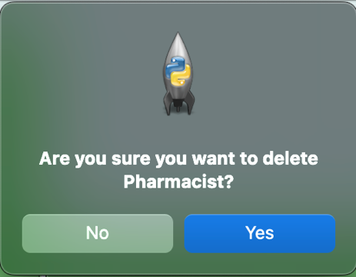

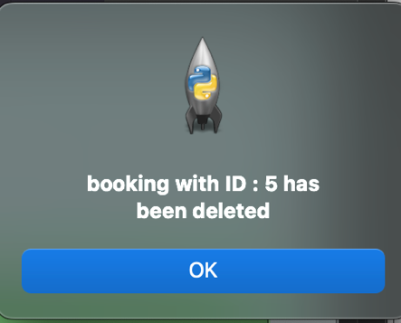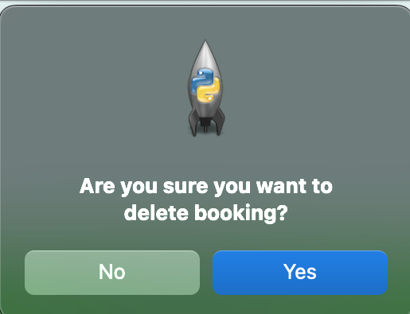

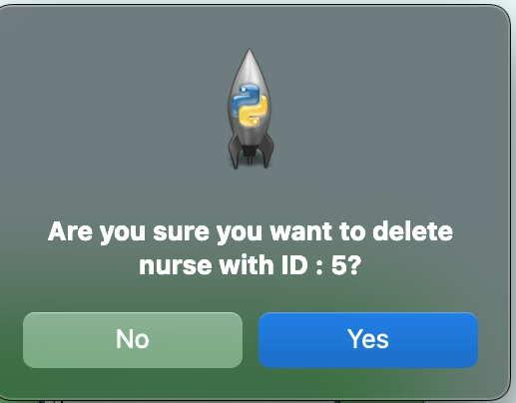

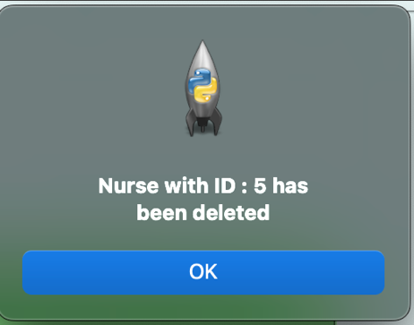

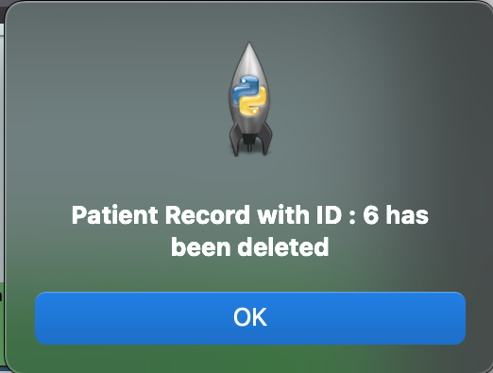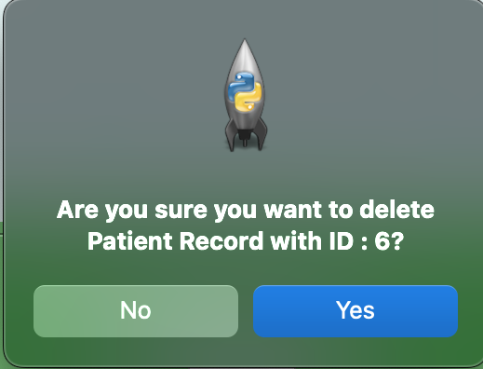

1. **Data Output**

|  |  |  |  |  |  |  |
| --- | --- | --- | --- | --- | --- | --- |
| Test Number | Test Purpose | Reason | Entry | Entry Type | Expected result | Test Result |
| 27. | Create Patient Text File | Click the Create list of all patients button |  |  | PatientList.txt file created | Passed |
| 28. | Create Pharmacist Text file | Click the create a list of all pharmacists button |  |  | Pharmacist.txt file created | Passed |
| 29. | Create Booking Text file | Click the create Booking output Button |  |  | Bookings.txt file created | Passed |



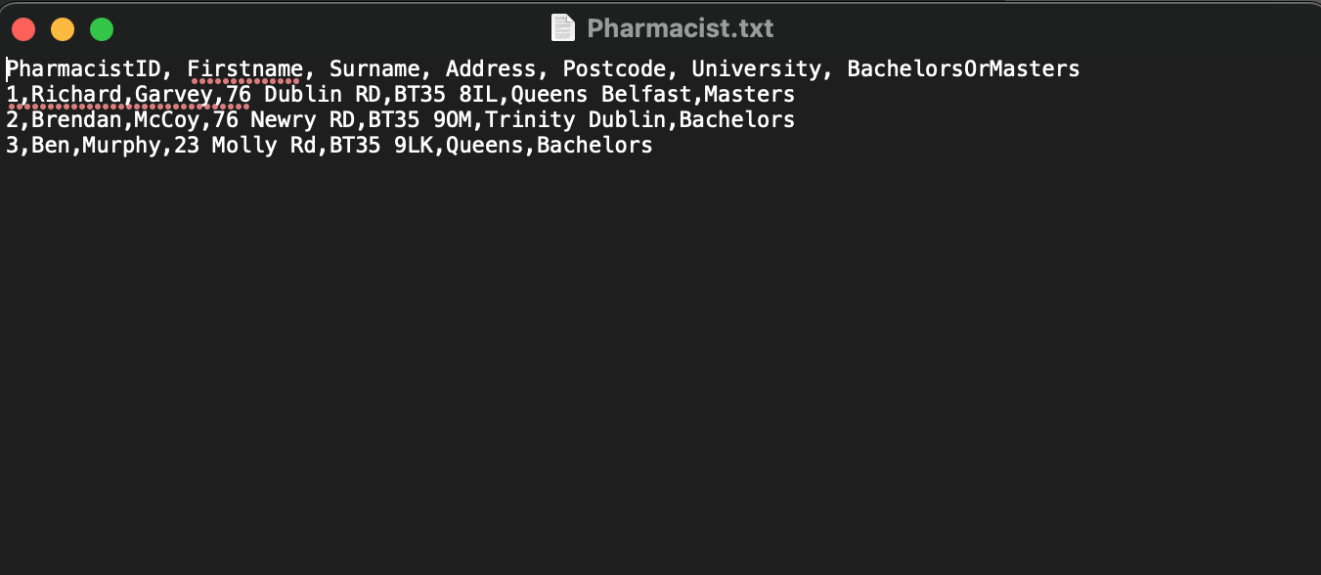

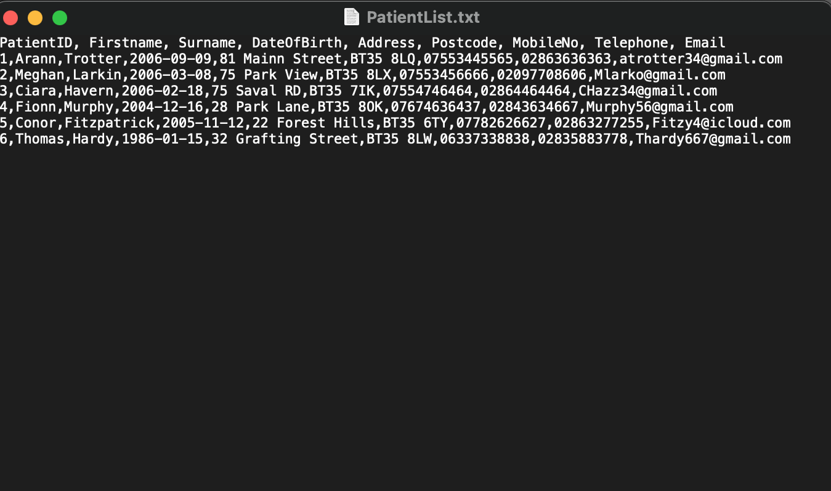

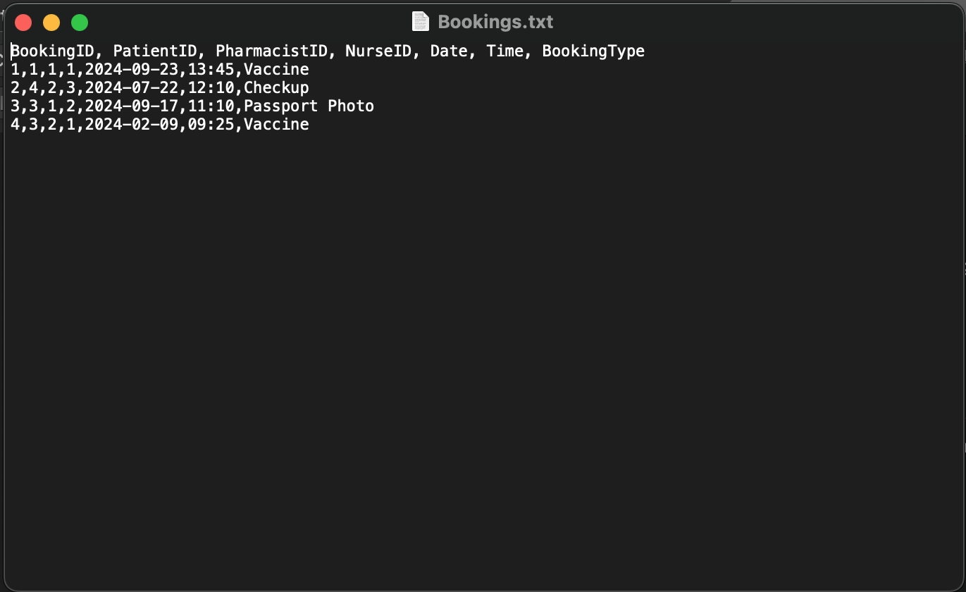

**System Functions**

|  |  |  |  |  |  |  |
| --- | --- | --- | --- | --- | --- | --- |
| Test Number | Test Purpose | Reason | Entry | Entry Type | Expected result | Test Result |
| 30. | Make sure that the new users button works and that the Register screen opens | Press the new user’s button |  |  | Register user screen opens | Passed |
| 31. | Make sure the Login screen opens after pressing the return to main menu button | Press the return to main menu button |  |  | Login screen reappears | Passed |
| 32. | Making sure the login screen reappears after creating a new user | Fill in new user details and click create new user button | Admin  Admin2  Frank3434! | Normal | Login screen reappears and message box appears to say a new user has been created | Passed |
| 33. | Ensure Password Validation works | Enter wrong password | Frank3434 | Erroneous | Error box appears | Passed |
| 34. | Make sure passwords are encrypted | Check data through a DB |  |  | Passwords are unreadable | Passed |
| 35. | Make sure login attempts works | Put in the wrong user details | Frank  Frank3434 | Erroneous | Window with login attempts left appears | Passed |

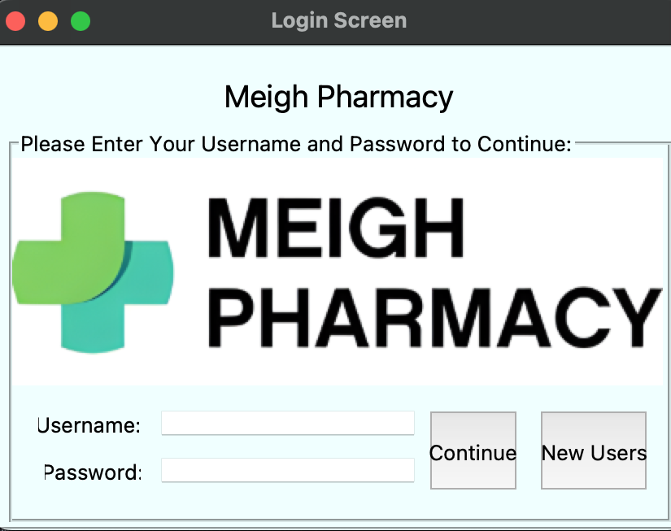

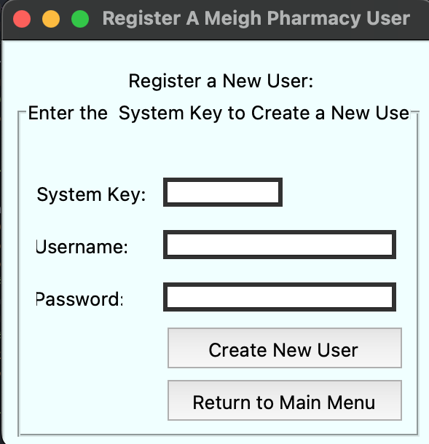

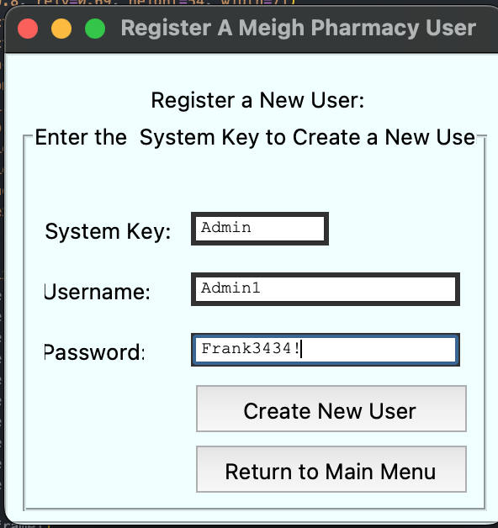

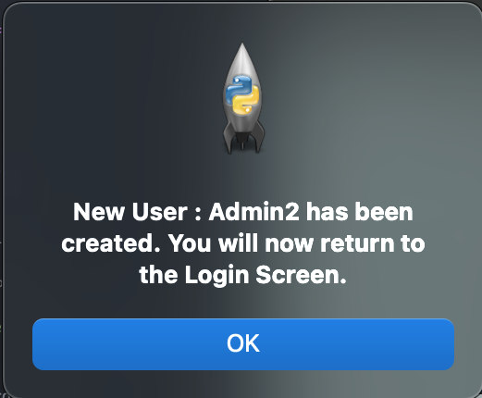

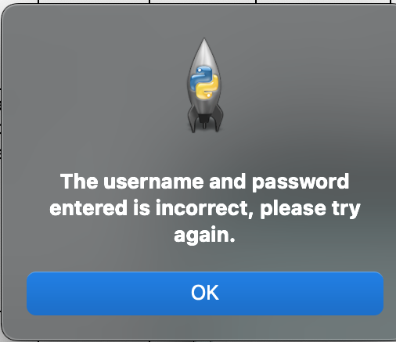

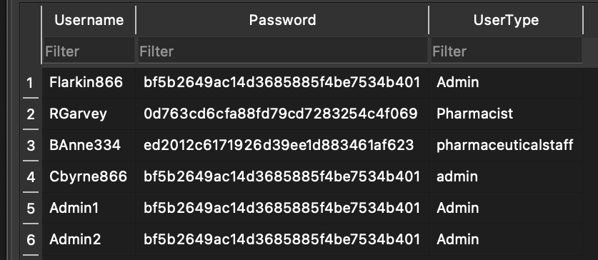

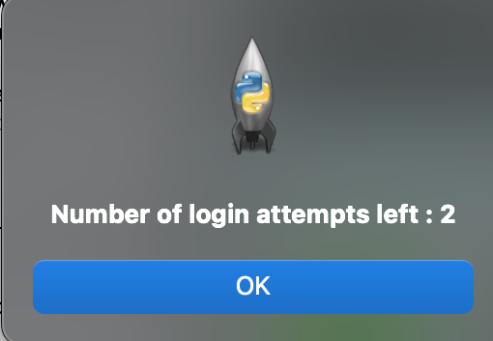

***Features that were either incomplete or not fully fulfilled***

Implementation of users Access levels

Initially I had wanted to have it where Pharmacists would not be able to edit their own details, nurses would not be able to view their own details, Patients would only be able to access their own records and Pharmacists having the ability to see all Patient and nurse Data. However, I was unable to add this feature to my system as it would have involved adding different Keys for different users and having the system determine the user type using a column in the login details, which would have been very complex to code and also very time consuming. Therefore, due to these constraints I was unable to add this feature.

Medicine Stock Table

Again, Initially I had wanted to add another table called medicine stock. This table would have served the Pharmacy shop and patients as it would have given them accurate stock levels for various medications. However, I found that due to the limited time frame of my project, creating this table would have required even more time due to having to create new validations. Below are the plans for the failed table.

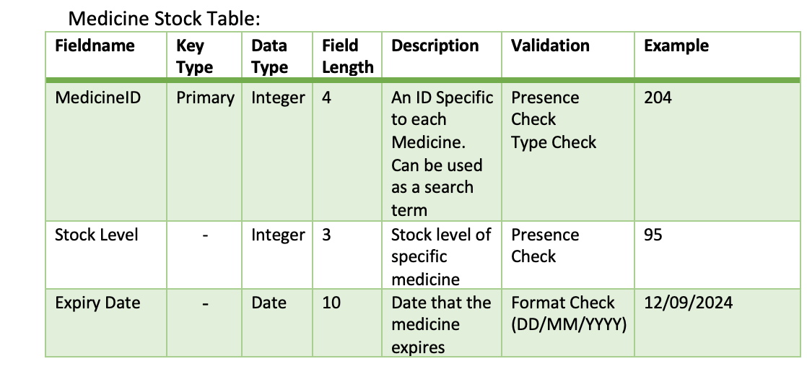

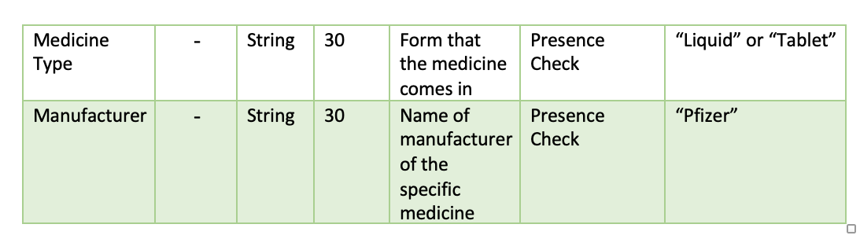

***Potential Changes or improvements of the system***

Viewing of data in the Database

If I had more time to improve the system, instead of just creating text files to view certain data in the Database I would implement tree view into my system. This would have allowed me to show Realtime data in the system however it would have been very hard to code as it would require code to constantly clear and update the data in the tree view. I would have also provided tree view to view more than just Patients, Bookings and Pharmacists. It would have included Nurses and Patient records. The tree view window would have been placed below the Entry fields and buttons and would have been colored to match the GUI.

GUI Design

I believe I could have made the design of my Main menu GUI more modern through the use of images. In the Patient Frame I added an image to help aid the look of the GUI however I believe I could have added more images in other tabs in order for the GUI to look more eye-catching and appealing.

***End User Sign Off***

Please sign below to affirm that all of the user requirements have been met to a satisfying standard.

User Signature: R. Garvey

Date: 27/04/2024